**Scenario:**

In an online shop management system, an online shop delivers many types of products to customers by delivery man in any location. An online shop has a dealer who is identical by their unique dealer id. A dealer has more attributes such as location from which they operate to, email and also their name. A dealer sells multiple products which gets acquired by a Seller. Each product has their unique id and they also have their name, size and color. Seller is identical to their unique trade license number and they have their usual name, phone number and the date which they started their business. Product has their prices which gets recorded by both the product and the seller who acquires it. There is also delivery man to deliver the products to the customers. A seller supplies the products to deliver to multiple delivery men. Each delivery man is recognized by their distinct delivery man id. They also have their name and the transport number which they use to deliver. There are many delivery men delivering products to many customers. Each customer has their unique nid for recognizing them separately and also, they are identical to their name, address and their account type in the online shop website.

**ER Diagram**:

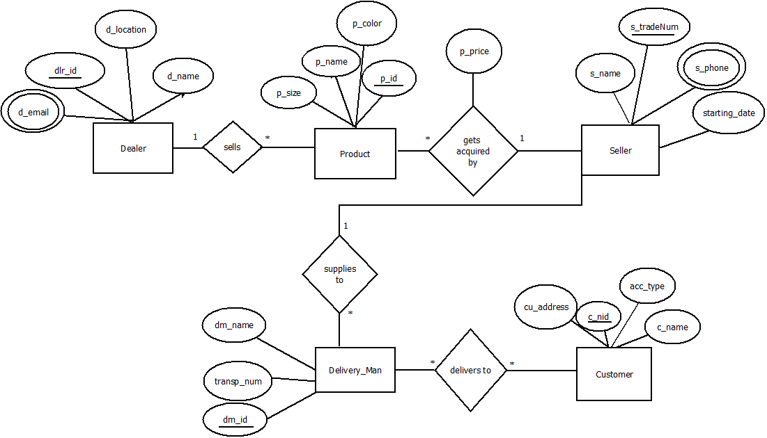

**Normalization**

Foreign Key

Primary Key

**Sells** (dlr_id, d_location, d_name, d_email, p_id, p_name, p_price, p_size, p_color)

1NF: d_email is a multivalued attribute

2NF: dlr_id, d_name, d_location, d_email

p_id, p_name, p_color, p_size, p_price

3NF: dlr_id, d_name, d_location, d_email

p_sizeid, p_size, p_price, p_color

p_id, p_name

Table for Sells:

1. dlr_id, d_name, d_location
2. p_sizeid, p_size, p_price, p_color
3. p_id, p_name, p_sizeid, dlr_id
4. dlr_id, d_email – composite primary key

**Gets acquired by** (p_id, p_size, p_name, p_color, p_price, s_name, s_tradeNum, s_phone, starting_date)

1NF: s_phone is a multivalued attribute

2NF: p_id, p_name, p_size, p_color, p_price

s_tradeNum, s_name, s_phone, starting_date

3NF: p_id, p_name

p_sizeid, p_size, p_price, p_color

s_tradeNum, s_name, s_phone, starting_date

Table for gets acquired by:

1. p_id, p_name, p_price, s_tradeNum, p_sizeid
2. p_sizeid, p_price, p_size, p_color
3. s_tradeNum, s_name, starting_date
4. s_tradeNum, s_phone-composite primary key

**Supplies to** (s_tradeNum, s_name, s_phone, starting_date, p_price, dm_id, transp_num, dm_name)

1NF: s_phone is a multivalued attribute

2NF: s_tradeNum, s_name, s_phone, p_price, starting_date

dm_id, dm_name, transp_num

3NF: No transitive dependency

s_tradeNum, s_name, s_phone, p_price, starting_date

dm_id, dm_name, transp_num

Table for Supplies to:

1. s_tradeNum, s_name, p_price, starting_date
2. dm_id, dm_name, transp_num, s_tradeNum
3. s_tradeNum, s_phone- composite primary key

**Delivers to** (dm_id, transp_num, dm_name, c_nid, cu_address, acc_type, c_name)

1NF: No multivalued Attribute

2NF: dm_id, dm_name, transp_num

c_nid, cu_address, acc_type, c_name

3NF: No transitive dependency

dm_id, dm_name, transp_num

c_nid, cu_address, acc_type, c_name

Table for delivers to:

1. dm_id, dm_name, transp_num
2. c_nid, cu_address, acc_type, c_name
3. t_id, dm_id, c_nid

Final Table List

1. dlr_id, d_name, d_location – **Dealer**
2. p_id, p_name, p_sizeid, dlr_id - **Product**
3. p_sizeid, p_size, p_price, p_color – **ProductInfo**
4. dlr_id, d_email – **Dealer1**
5. p_id, p_name, p_price, s_tradeNum, p_sizeid – **Product1**
6. s_tradeNum, s_name, p_price, starting_date - **Seller**
7. s_tradeNum, s_phone – **Seller1**
8. dm_id, dm_name, transp_num, s_tradeNum – **DeliveryMan**
9. c_nid, cu_address, acc_type, c_name - **Customer**
10. t_id, dm_id, c_nid - **TrackDelivery**

**Screenshots:**

**Dealer:**

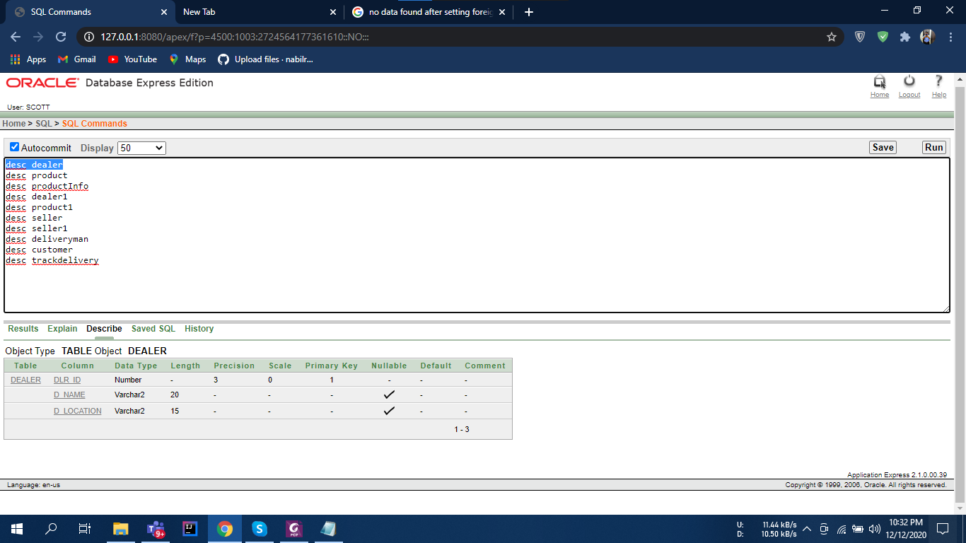

**Product:**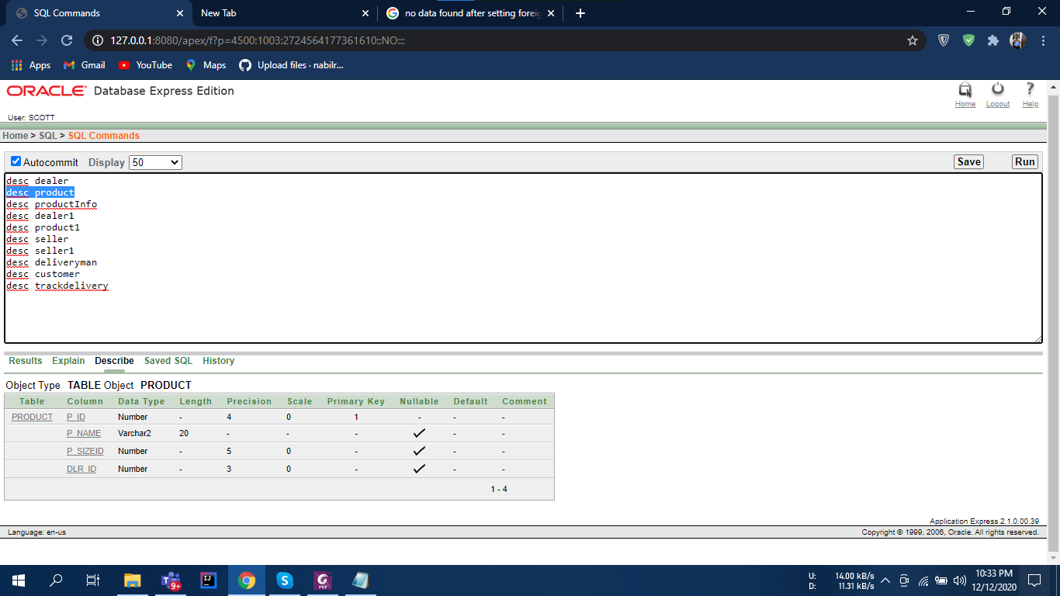

**Product Info**

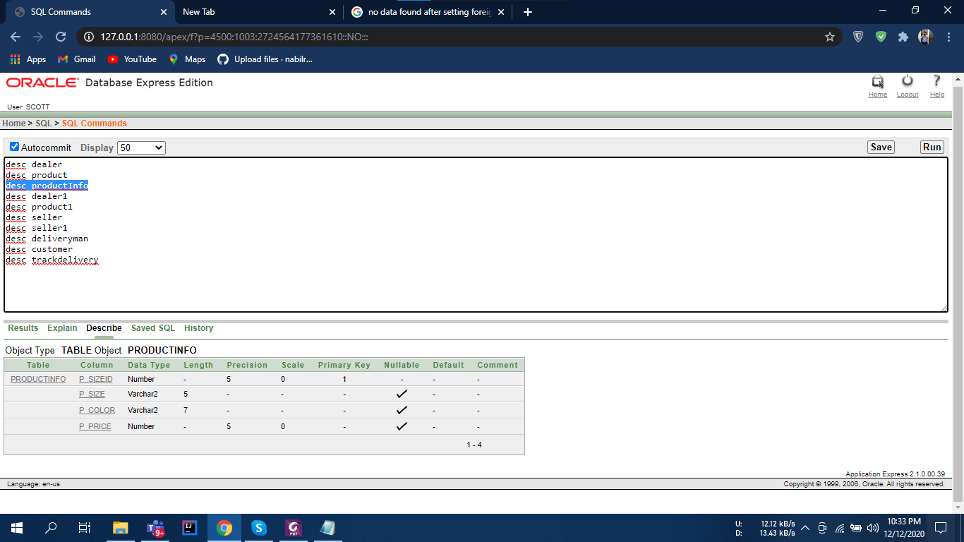

**Dealer 1:**

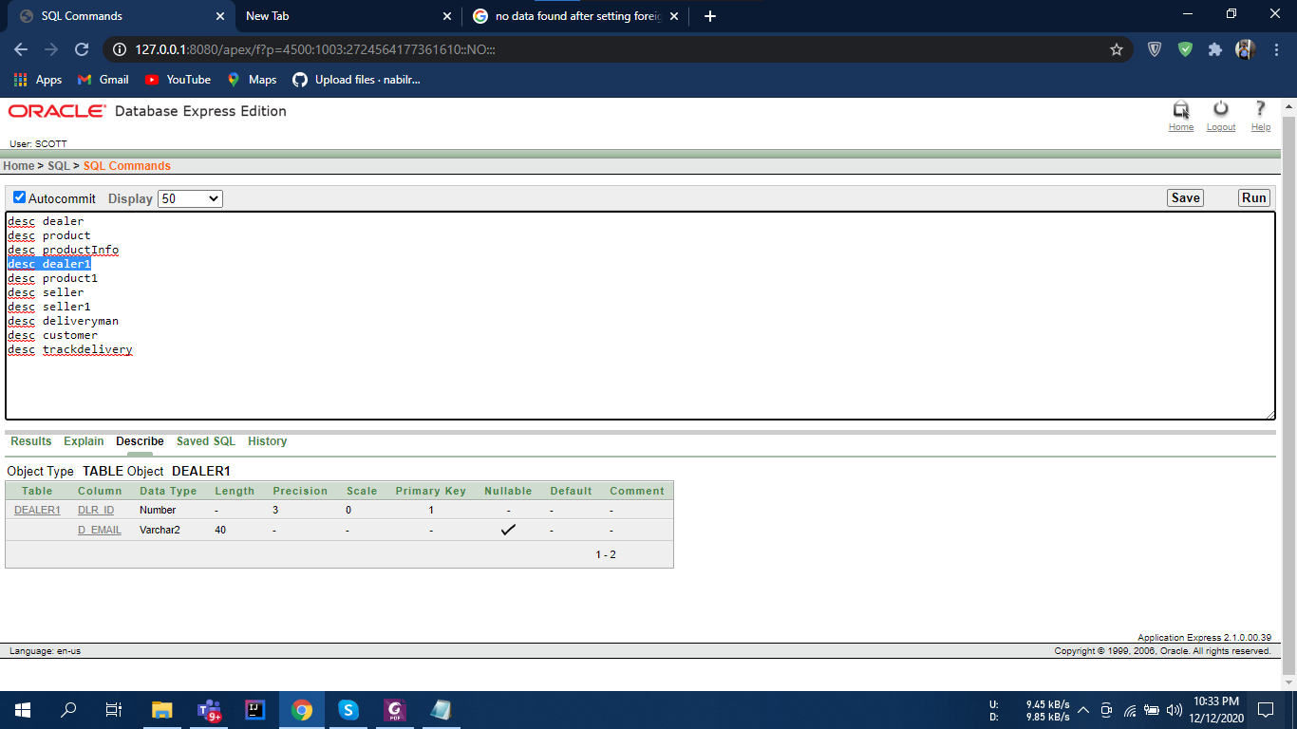

**Product 1:**

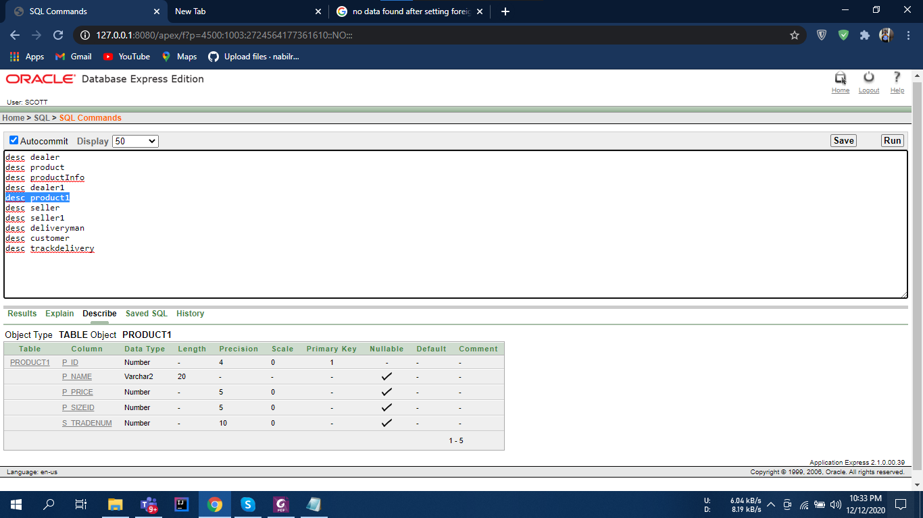

**Seller:** 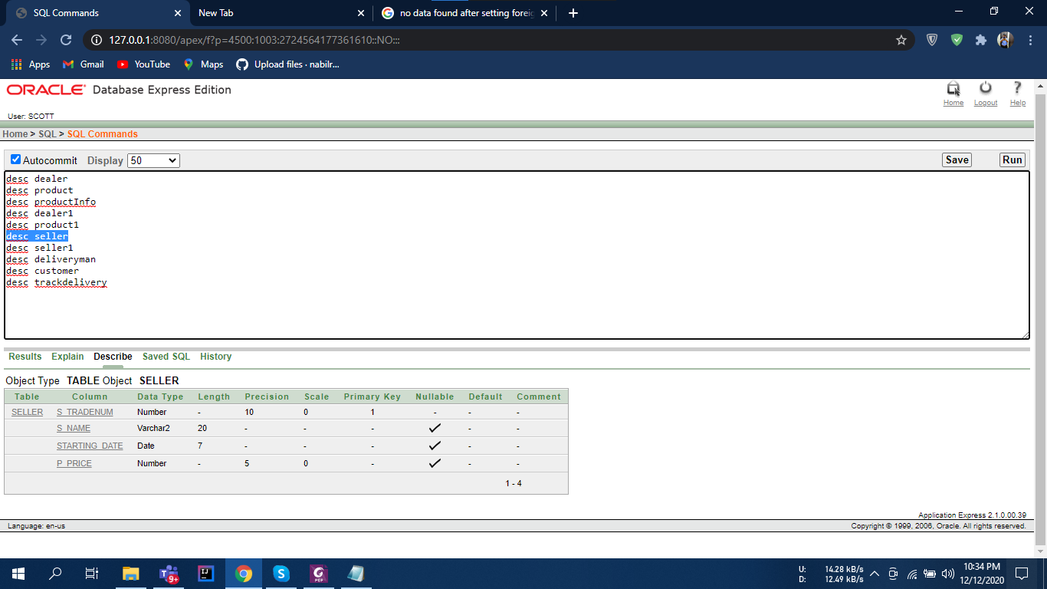

**Seller 1:**

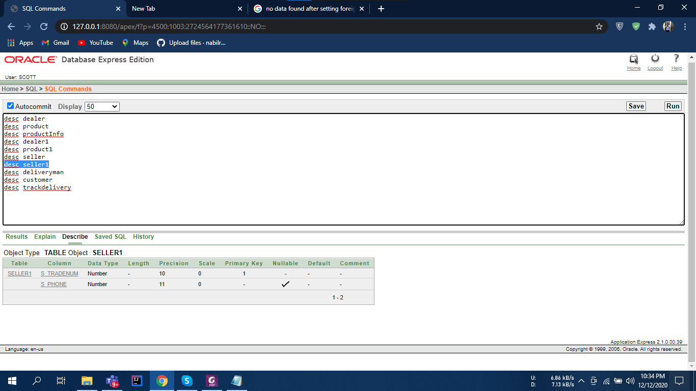

**Delivery Man:** 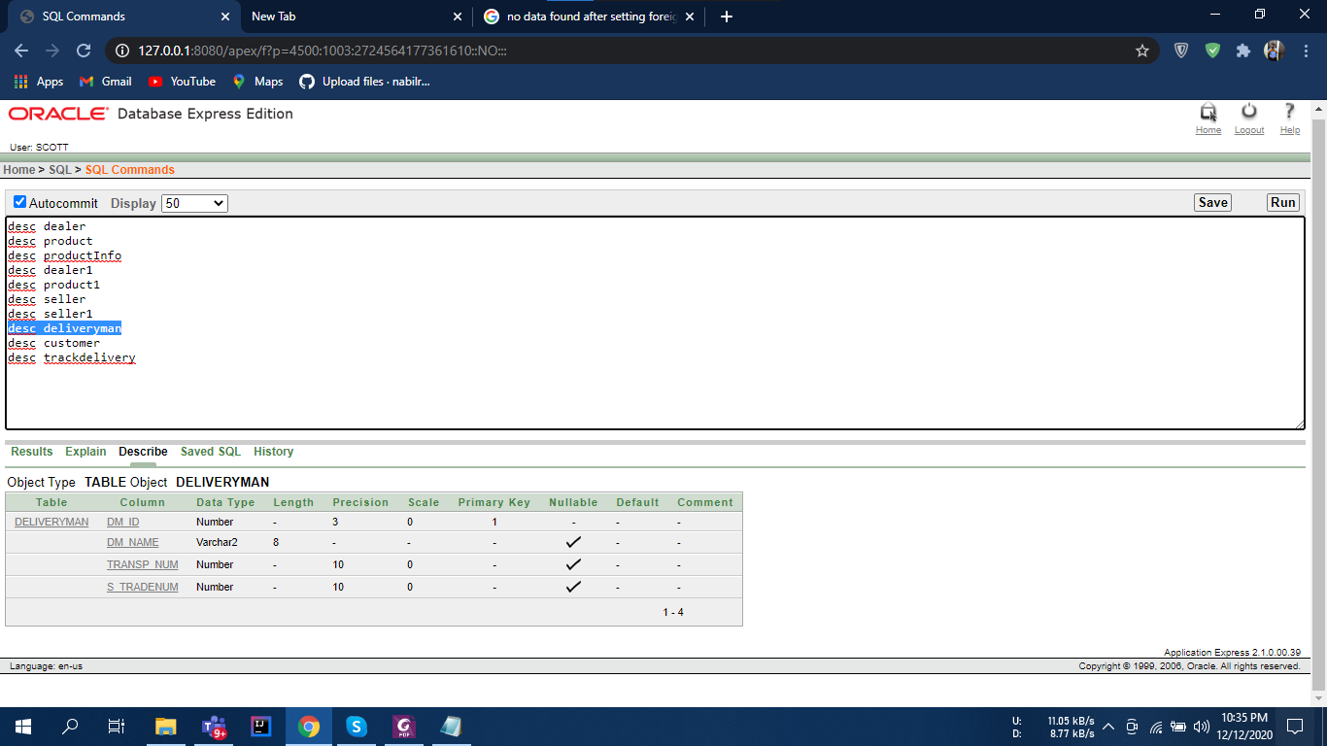

**Customer:**

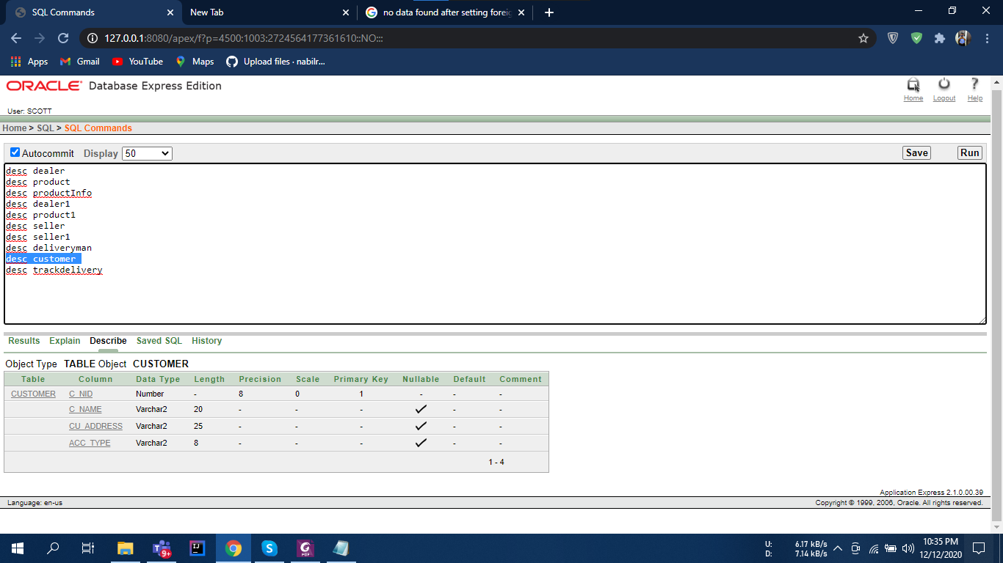

**Track Delivery:**

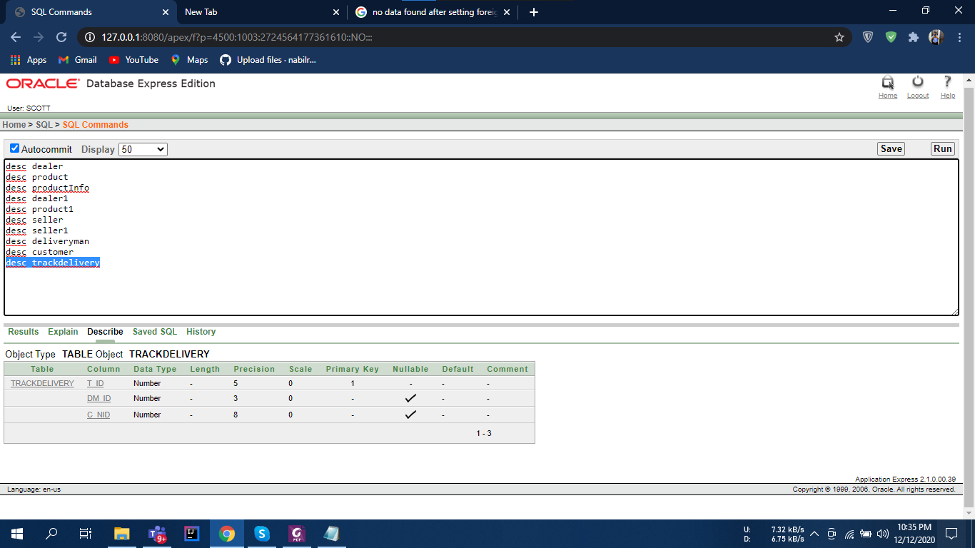

**Dealer:**

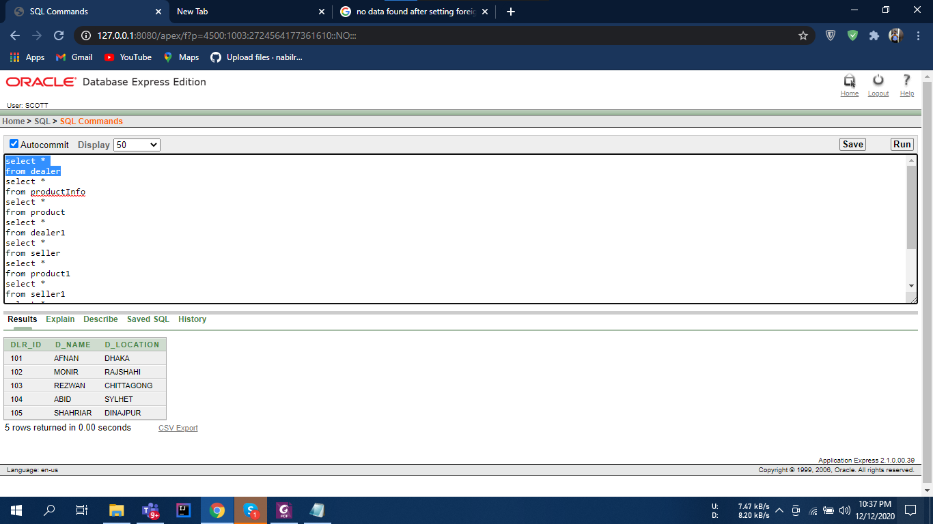

**Product Info:**

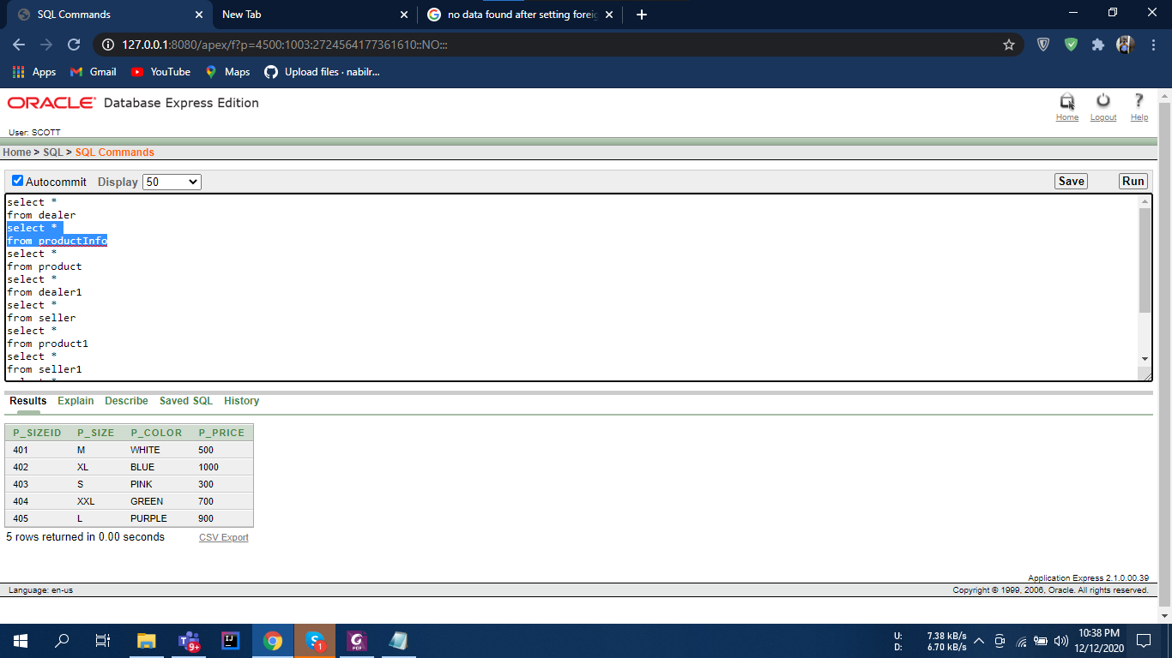

**Product:**

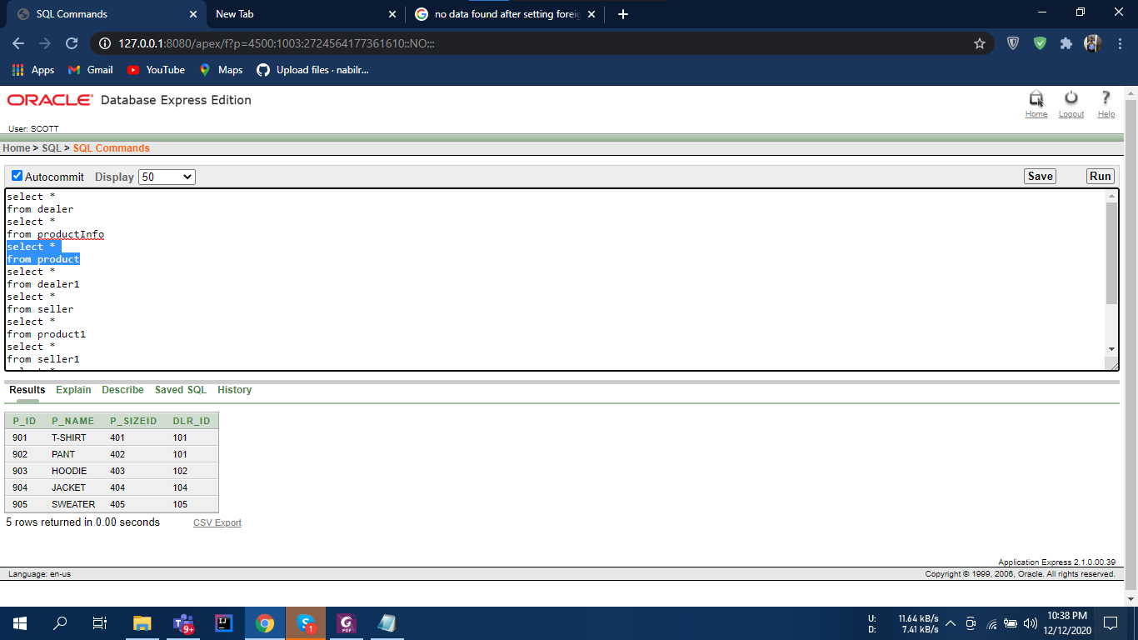

**Dealer 1:**

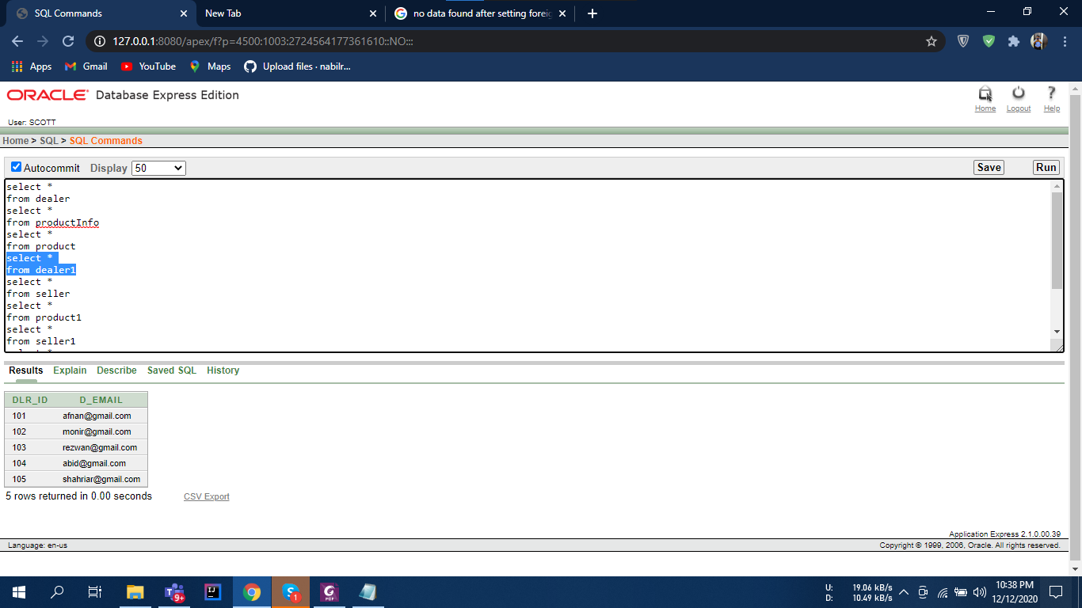

**Seller:**

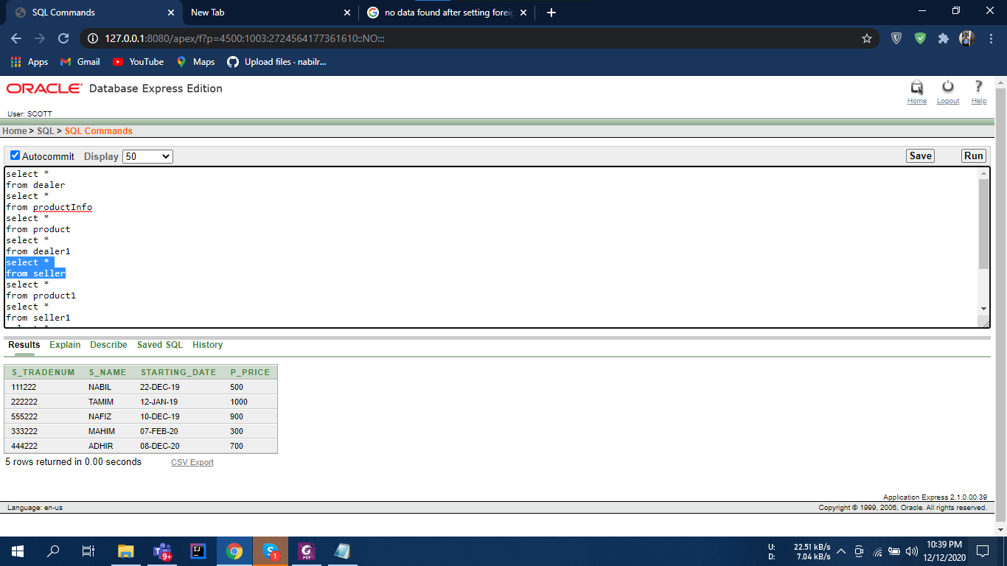

**Product 1:**

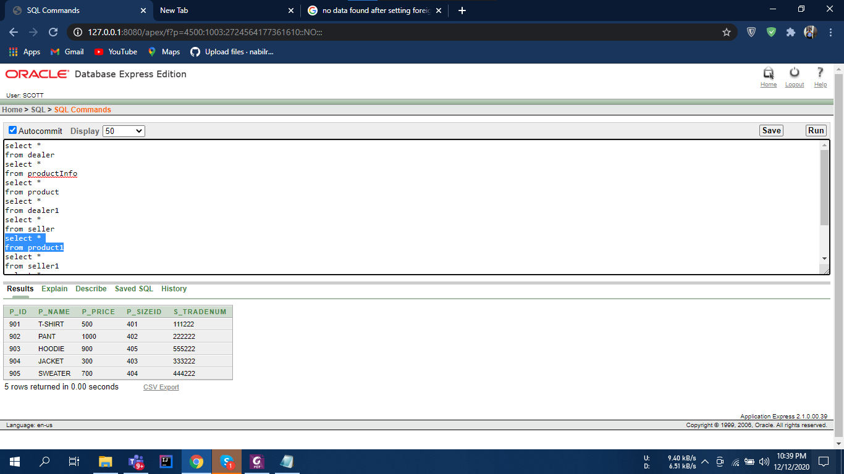

**Seller 1:**

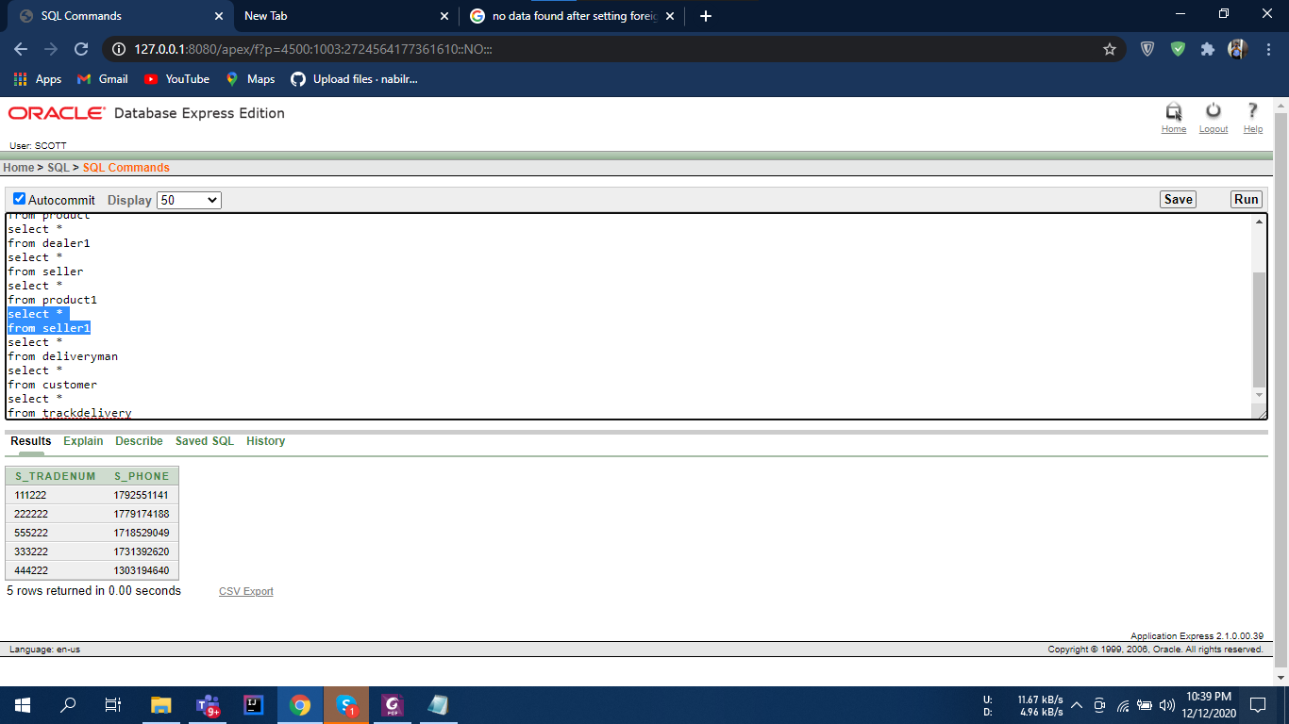

**Delivery Man:**

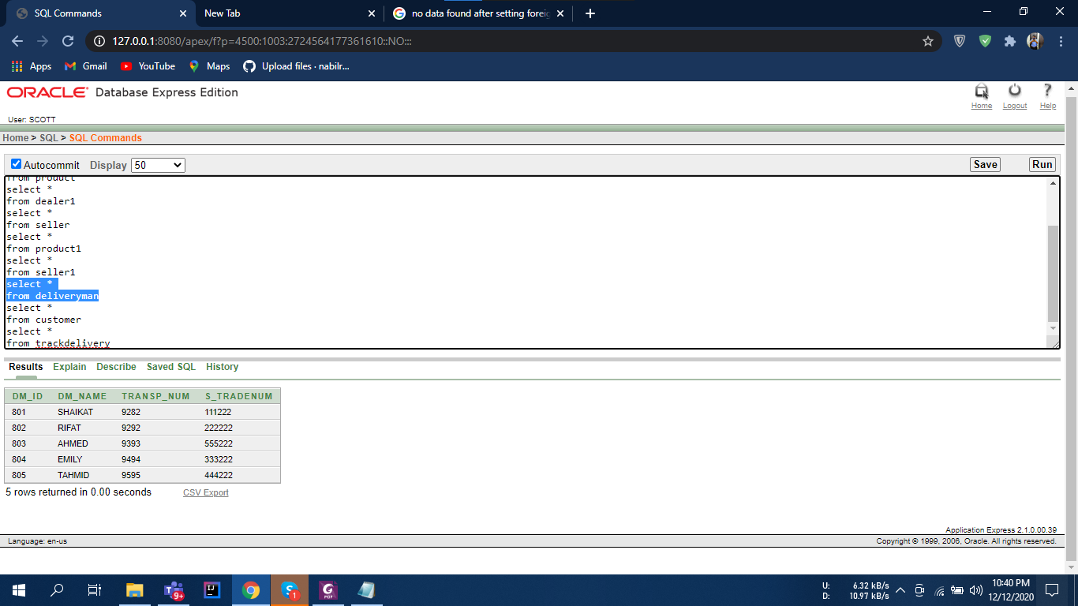

**Customer:**

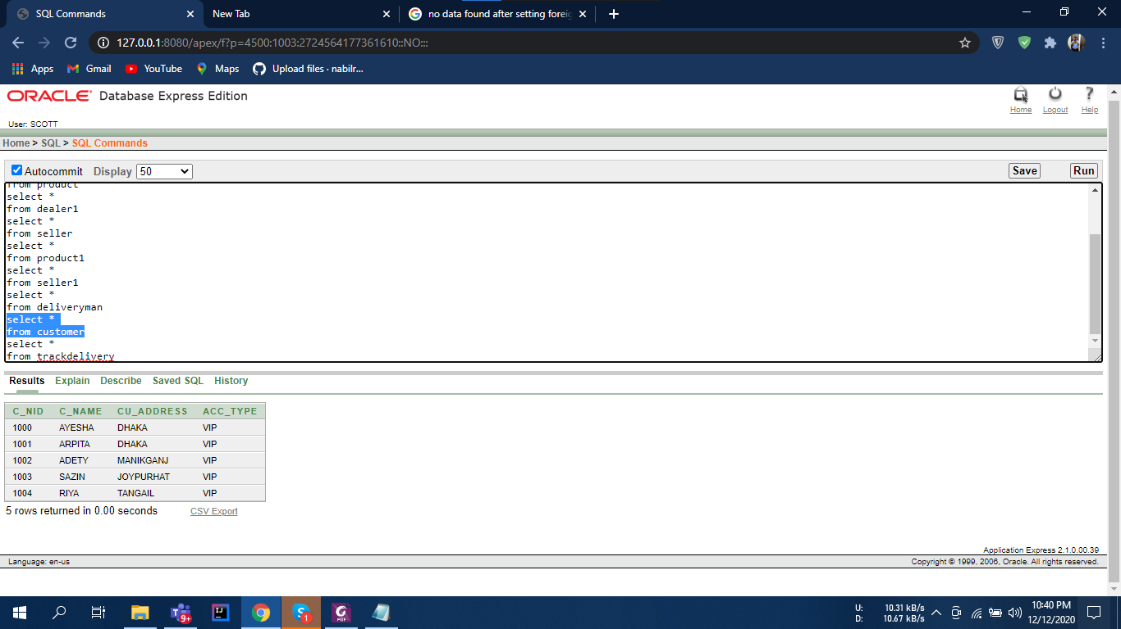

**Track Delivery:**

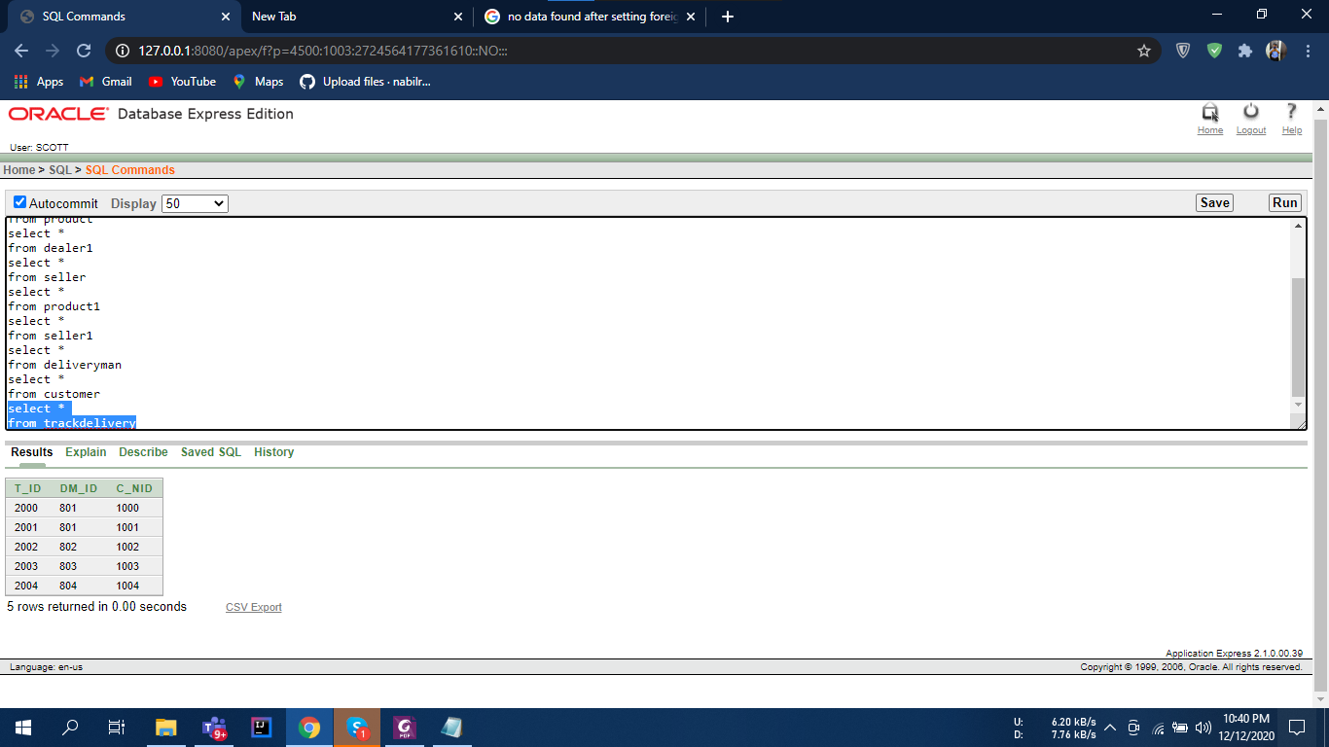

**Constraints used:**

* Primary Key
* Foreign Key
* Not Null
* Unique

**Primary Key, Foreign Key, Not Null**

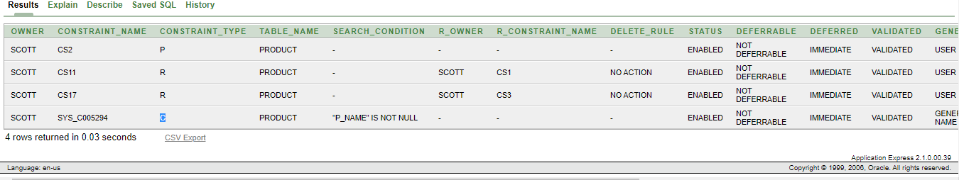

**Primary Key, Unique**

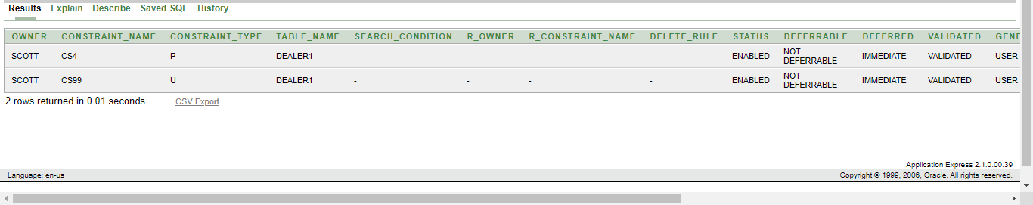

**NB:** Foreign key has been used as the final table of normalization suggest in that manner. The two screenshots given upwards are there to give a view of two other constraint being used, unique and not null.

**Questions:**

Single Row Function

1.Write a query to display the information of customers whose name starts with A and address starts with D and their account type, rename the customer name column to customer and customer address column to Address.

2.Write a query to display since how many months Mahim has started his business give that column an appropriate name also rounds up the months.

Multiple Row Function

3.Write a query to display the total number of sellers needed to add to have 100 sellers in your database also give an appropriate name to that column.

4.Write a query to display name and the most expensive clothing's price with 15% vat then show all the cloth's price with same condition, give the column an appropriate name.

Subquery (Single and Multiple row)

5.Write a query to display the name and price of the clothing which costs more than Hoodie.

6.Write a query to display the names and price of those clothing’s who are priced higher than the lowest

Join

7.Write a query display the delivery men names and prices of those who delivers product which cost more than 800 takas

8.Write a query to display the product name, product size id, seller name, starting date and price who sells pant and the name starts with T

Sequence and View

9.Write a query to create a sequence which will start from 10 will increase by 2 max value is 100 no cycle no cache

10. Create a view for products so that the user can only see or read the product id, product name and price.

**Extras:**

**All the Queries for the project**

**Tables:**

create table Dealer(

dlr_id number(3),

d_name varchar2(20),

d_location varchar2(15))

create table Product(

p_id number(4),

p_name varchar2(20),

p_sizeid number(5),

dlr_id number(3))

create table ProductInfo(

p_sizeid number(5),

p_size varchar2(5),

p_color varchar2(7),

p_price number(5))

create table Dealer1(

dlr_id number(3),

d_email varchar2(40))

create table Product1(

p_id number(4),

p_name varchar2(20),

p_price number(5),

p_sizeid number(5),

s_tradeNum number(10))

create table Seller(

s_tradeNum number(10),

s_name varchar2(20),

starting_date date,

p_price number(5))

create table Seller1(

s_tradeNum number(10),

s_phone number(11))

create table DeliveryMan(

dm_id number(3),

dm_name varchar2(8),

transp_Num number(10),

s_tradeNum number(10))

create table Customer(

c_nid number(8),

c_name varchar2(20),

cu_address varchar2(25),

acc_type varchar2(8))

create table TrackDelivery(

t_id number(5),

dm_id number(3),

c_nid number(8))

**Setting the primary keys:**

alter table dealer add constraint cs1 primary key(dlr_id)

alter table product add constraint cs2 primary key(p_id)

alter table ProductInfo add constraint cs3 primary key(p_sizeid)

alter table Dealer1 add constraint cs4 primary key(dlr_id)

alter table Product1 add constraint cs5 primary key(p_id)

alter table Seller add constraint cs6 primary key(s_tradeNum)

alter table Seller1 add constraint cs7 primary key(s_tradeNum)

alter table DeliveryMan add constraint cs8 primary key(dm_id)

alter table Customer add constraint cs9 primary key(c_nid)

alter table TrackDelivery add constraint cs10 primary key(t_id)

**Setting the foreign keys:**

alter table product add constraint cs11 foreign key (dlr_id) references Dealer(dlr_id)

alter table product add constraint cs17 foreign key (p_sizeid) references ProductInfo(p_sizeid)

alter table product1 add constraint cs12 foreign key (s_tradeNum) references Seller(s_tradeNum)

alter table product1 add constraint cs13 foreign key (p_sizeid) references ProductInfo(p_sizeid)

alter table DeliveryMan add constraint cs14 foreign key (s_tradeNum) references Seller(s_tradeNum)

alter table TrackDelivery add constraint cs15 foreign key (dm_id) references DeliveryMan(dm_id)

alter table TrackDelivery add constraint cs16 foreign key(c_nid) references Customer(c_nid)

**Setting the Unique and not null constraints:**

alter table product modify(p_name not null)

alter table dealer1 add constraint cs99 unique(d_email)

**Description of All the tables:**

desc dealer

desc product

desc productInfo

desc dealer1

desc product1

desc seller

desc seller1

desc deliveryman

desc customer

desc trackdelivery

**Inserting the values into the column:**

select *

from dealer

Insert into dealer values(101,'AFNAN','DHAKA')

Insert into dealer values(102,'MONIR','RAJSHAHI')

Insert into dealer values(103,'REZWAN','CHITTAGONG')

Insert into dealer values(104,'ABID','SYLHET')

Insert into dealer values(105,'SHAHRIAR','DINAJPUR')

select *

from productInfo

Insert into productinfo values(401,'M','WHITE',500)

Insert into productinfo values(402,'XL','BLUE',1000)

Insert into productinfo values(403,'S','PINK',300)

Insert into productinfo values(404,'XXL','GREEN',700)

Insert into productinfo values(405,'L','PURPLE',900)

select *

from product

Insert into product values(901,'T-SHIRT',401,101)

Insert into product values(902,'PANT',402,101)

Insert into product values(903,'HOODIE',403,102)

Insert into product values(904,'JACKET',404,104)

Insert into product values(905,'SWEATER',405,105)

select *

from dealer1

Insert into dealer1 values(101,'afnan@gmail.com')

Insert into dealer1 values(102,'monir@gmail.com')

Insert into dealer1 values(103,'rezwan@gmail.com')

Insert into dealer1 values(104,'abid@gmail.com')

Insert into dealer1 values(105,'shahriar@gmail.com')

select *

from seller

Insert into seller values(111222,'NABIL',to_date('22-12-2019','dd-mm-yyyy'),500)

Insert into seller values(222222,'TAMIM',to_date('12-1-2019','dd-mm-yyyy'),1000)

Insert into seller values(333222,'MAHIM',to_date('7-2-2020','dd-mm-yyyy'),300)

Insert into seller values(444222,'ADHIR',to_date('8-12-2020','dd-mm-yyyy'),700)

Insert into seller values(555222,'NAFIZ',to_date('10-12-2019','dd-mm-yyyy'),900)

select *

from product1

Insert into product1 values(901,'T-SHIRT',500,401,111222)

Insert into product1 values(902,'PANT',1000,402,222222)

Insert into product1 values(903,'HOODIE',900,405,555222)

Insert into product1 values(904,'JACKET',300,403,333222)

Insert into product1 values(905,'SWEATER',700,404,444222)

select *

from seller1

Insert into seller1 values(111222,01792551141)

Insert into seller1 values(222222,01779174188)

Insert into seller1 values(555222,01718529049)

Insert into seller1 values(333222,01731392620)

Insert into seller1 values(444222,01303194640)

select *

from deliveryman

Insert into deliveryman values(801,'SHAIKAT',9282,111222)

Insert into deliveryman values(802,'RIFAT',9292,111222)

Insert into deliveryman values(803,'AHMED',9393,333222)

Insert into deliveryman values(804,'EMILY',9494,444222)

Insert into deliveryman values(805,'TAHMID',9595,222222)

select *

from customer

Insert into customer values(1000,'AYESHA','DHAKA','VIP')

Insert into customer values(1001,'ARPITA','DHAKA','VIP')

Insert into customer values(1002,'ADETY','MANIKGANJ','VIP')

Insert into customer values(1003,'SAZIN','JOYPURHAT','VIP')

Insert into customer values(1004,'RIYA','TANGAIL','VIP')

select *

from trackdelivery

Insert into trackdelivery values(2000,801,1000)

Insert into trackdelivery values(2001,801,1001)

Insert into trackdelivery values(2002,802,1002)

Insert into trackdelivery values(2003,803,1003)

Insert into trackdelivery values(2004,804,1004)